Project Design Phase
Solution Architecture
Date | 14 July 2026
Team ID
Project Name | HouseRent India — MERN Property Rental & Sale Platform
Maximum Marks | 4 Marks

Solution Architecture:
HouseRent India uses a classic 3-tier MERN architecture: a React single-page frontend, a stateless Express REST API, and a MongoDB document store, with JWT-based authentication and role-based middleware controlling access across the Renter/Buyer, Owner, and Admin roles.

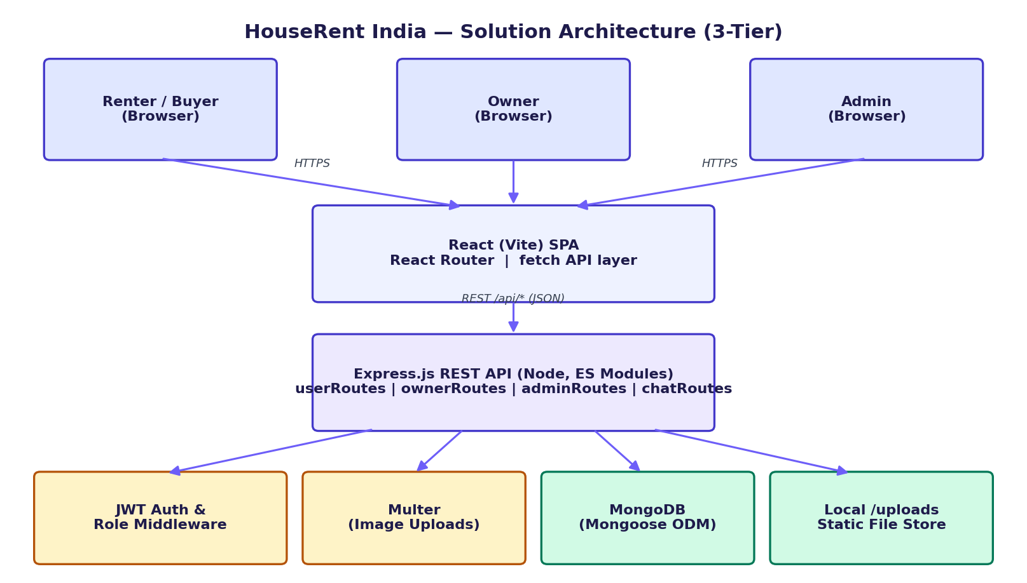
Figure 1: HouseRent India — 3-tier solution architecture

Architecture Layers:
Layer | Description
Presentation Layer | React 18 (Vite) single-page app with React Router; three role-scoped module trees (common, user/owner, user/renter, admin, chat); plain fetch calls (no Axios) centralised in api.js; auth.js manages the JWT/user in browser storage.
API / Application Layer | Node.js + Express (ES modules); route files (userRoutes, ownerRoutes, adminRoutes, chatRoutes) contain their own request logic; auth.js middleware verifies JWTs and enforces role checks; upload.js (Multer) handles multipart image uploads.
Data Layer | MongoDB accessed via Mongoose ODM; four core collections — User, Property, Booking, Message — connected through db.js; a compound unique index on (email, role) allows one email to hold both a Renter and an Owner account.
Cross-Cutting Concerns | JWT authentication + role-based authorization; bcryptjs password hashing; CORS configuration; environment-based configuration via dotenv; static file serving of uploaded property images from /uploads.

Key Flows:
- Auth: Register/Login → password hashed/verified with bcryptjs → JWT issued → stored client-side → sent as Bearer token on subsequent requests.
- Listing: Owner submits property form + images → Multer stores files under /uploads, saves metadata to MongoDB via Property model.
- Booking: Renter/Buyer submits a request → stored in Booking collection (status: pending) → Owner approves/rejects → status updates propagate back to the renter's "My Bookings" view.
- Chat: Once a Booking exists, either party can post to its Message thread; the client polls every ~4 seconds for new messages.
- Moderation: Admin flags a Property with a reason (removalRequest: pending) → Owner consents or declines → only consent sets status to removed.

